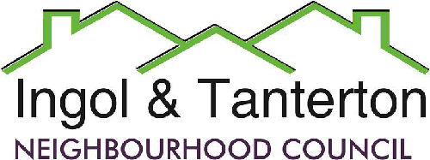

Gill Mason - Clerk and RFO

Email: [ingoltantertonnc@hotmail.co.uk](mailto:ingoltantertonnc@hotmail.co.uk)

**Minutes of the Ingol and Tanterton Neighbourhood Council Finance and Asset Committee held on Monday 6th January 2025 at 7.15pm at Tanterton Village Centre.**

Present: Cllr Darby, Cllr Jewell. Cllr Ellison.

**Open forum**

No public present.

**FC50 To receive apologies.**

None.

.

**FC51To approve the minutes of the December Finance Committee Meeting.**

It was resolved that the minutes be approved.

Proposed by Cllr Darby.

Seconded by Cllr Jewell.

**FC52 To review the draft budget for 2025/2026.**

It was resolved to propose to full council that the precept per Band D be raised by 4.98% and that £350,000 from the Unity current account be transferred to the savings account to accrue interest.

Proposed by Cllr Jewell.

Seconded by Cllr Ellison.

Meeting closed at 8pm.